Algebra
Mr. Barnes
Unit 1 Test Review
Answers are at http://haveaproblem.net

- Mr. Barnes needs your help planning a trip to Yosemite. From Mr. Barnes’s house to the cabin in which he will be staying is 220 miles. It will take him 4 hours to get there.

A. Please create a t-table and a graph that models Mr. Barnes’s trip.

B. What will his average speed be for this trip?

C. Can you declare variables and create a function that describes Mr.
Barnes’s time and distance?

D. What is the Domain and Range of this function?
- The function C = $\frac{5}{9}$(F – 32) converts Fahrenheit temperature inputs to Celsius temperature outputs.

- What would a temperature of 41º F degrees be in Celsius?

- What would a temperature of 49º F be in Celsius?

- How about 94º F?

- Please make a t-table and graph of this function.

E. What is the Domain and Range of this function?

- The function f(x) = -16x² + 64 describes the relationship between time (x, the input) and distance from the ground (y, the output) of an eggplant dropped off of a roof.

- What is the Domain of this Function?

- Please make a t-table for this function starting with an input of 0 and going up by half-seconds.

- Please make a graph for this function.

- What is the Range of this function?
- Are these functions? Why or why not?

A.

Input (x) | 2 | 3 | 4 | 5 | 6
Output (y) | 4 | 4 | 4 | 4 | 4

B.

Input (x) | 2 | 6 | 8 | 3 | 6
Output (y) | 1 | 2 | 3 | 4 | 5

C.

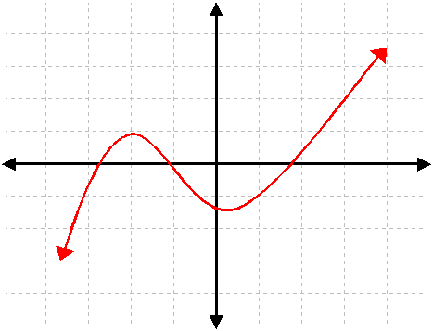

D.
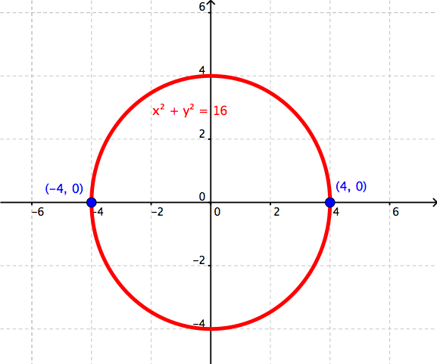

5. Explain in your own words: What is a function and how can we use it?

