Name:
8th Grade Algebra
Unit 3 Practice Test: Linear Functions
1. What is a function? Explain in your own words and give an example.

2. What is a linear function? What makes some functions linear and others not linear?

3. What is slope intercept form?

4. On graph paper, please graph the following linear functions on separate coordinate graphs:
a. y = 3
b. y = -2x
c. y = $\frac{2}{3}$x
d. y = - $\frac{1}{4}$x + 2
e. y = 3x – 4
f. 2x – 4y = 12 (get into slope-intercept form first)
5. Complete this ratio table:
3 |  | 9 |  | 13.5
8 | 16 |  | 20

6. Convert these functions into slope-intercept form, showing algebraic steps and keeping the equations balanced:

3x + 2y = -6 | x + 6 + y = 0
x – y = 8 | 12x – 14y = (-9)

7. Please find the intercepts of 30x – 5y = 65.

x-intercept y-intercept

8. Please find the slope of a line that goes through the points (-9, 0) and (3, -4).

9. What is the slope of this line?
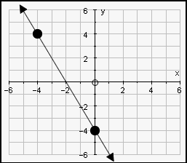

10. What is the equation of the line that has a slope of 4 and a y-intercept of 19?

11. What is the equation of the line that has a slope of -$\frac{1}{3}$ and passes through
(-4, 5)?
12. As the quality of water improves (input), the life expectancy gets longer. The people of Angola are living longer lives as a result of better water quality.

Make a model of a linear function using these two data points.

